***Verifying the Relationships of Newton's 2nd Law Name:___________ Inq: ____/12 Com:____/10***

**Purpose:** To understand relationships between mass, net force and acceleration in Newton’s 2nd Law.

**Predictions: [ 2 marks- Inq]**

How will NET FORCE impact acceleration if the mass of a system is constant?

How will MASS impact acceleration if the net force acting on the system is constant?

**Instructions:**

1. Login in to Explore Learning Gizmos and run Fan Cart Physics.
2. Select the Bar Chart Tab and click SHOW numerical values.
3. Determine the acceleration of the system for various masses and fans added to the cart.

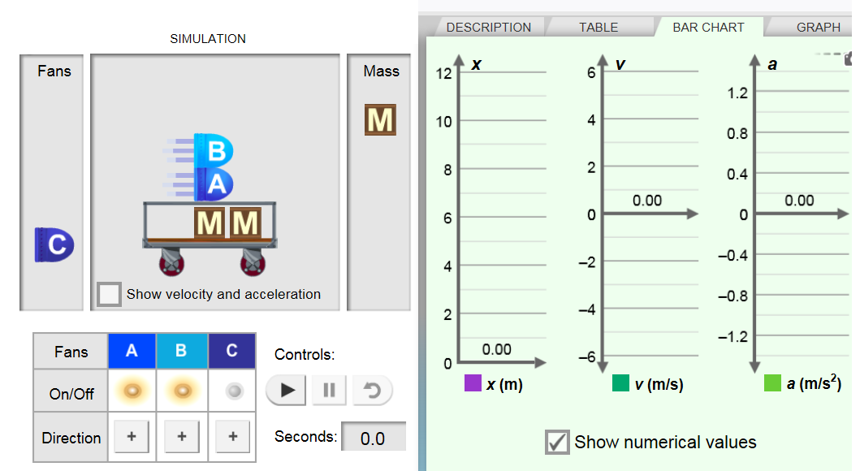**NOTE: To investigate FORCE we must keep __________ of the system constant. To investigate MASS we must keep the ________ constant.**

**Masses:**

**Cart 1.25 kg**

**Fan: 1.25 kg**

**Mass, M: 2.50 kg**

**Each FAN produces 2.0 N of thrust force**

**Observations:**

**Table 1: Acceleration versus Applied Force for Constant Total Mass [1 mark INQ]**

|  |  |  |  |  |  |  |
| --- | --- | --- | --- | --- | --- | --- |
| Trial | *Cart conditions* | | Fan conditions | Total Mass (kg) | Net Force (N) | Acceleration (m/s2) |
| Trial A | | Cart + 3 fans + 1 mass | All 3 fans on |  |  |  |
| Cart + 3 fans + 1 mass | 2 fans on |  |  |  |
| Cart + 3 fans + 1 mass | 1 fan on |  |  |  |
| Trial B | | Cart + 3 fans + 2 masses | All 3 fans on |  |  |  |
| Cart + 3 fans + 2 masses | 2 fans on |  |  |  |
| Cart + 3 fans + 2 masses | 1 fan on |  |  |  |
| Trial C | | Cart + 3 fans + 3 masses | All 3 fans on |  |  |  |
| Cart + 3 fans + 3 masses | 2 fans on |  |  |  |
| Cart + 3 fans + 3 masses | 1 fan on |  |  |  |

**Analysis: Plot a graph of Applied Force versus Acceleration for the three trials. Include (0,0) for all three plots. Draw three best fit lines or curves and include a legend. [ 4 marks INQ]**

**Table 2: Acceleration versus Mass for a Constant Force of _______ [1 mark INQ]**

|  |  |  |  |  |
| --- | --- | --- | --- | --- |
| *Cart conditions* | Fan conditions | Net Force (N) | Total Mass  Mtotal (kg) | Acceleration (m/s2) |
| Cart + 1 fan | 1 fan on |  |  |  |
| Cart + 2 fans | 1 fan on |  |  |  |
| Cart + 3 fans | 1 fan on |  |  |  |
| Cart + 3 fans + 1 mass | 1 fan on |  |  |  |
| Cart + 3 fans + 2 masses | 1 fan on |  |  |  |
| Cart + 3 fans + 3 masses | 1 fan on |  |  |  |

**Analysis: Plot a graph of Mass versus Acceleration for the case of constant applied force (Table 2). Draw a best fit line or curve through the data. [ 4 marks INQ]**

**Discussion and Conclusion [ 10 marks Com]:**

1. Refer to Table 1 and discuss how the acceleration depended upon the applied force. Give an example to support your answer. [2 Inq]
2. a) Describe the general trends of the plots in graph 1. What type of relationship is shown? [1 Inq]

b) Provide an explanation for the differences you see in the three plots in graph 1. [1 Inq]

1. Refer to Table 2 and discuss how acceleration depended upon the mass. Give an example to support your answer. [2 Inq ]
2. Describe the shape of graph 2. What type of relationship is illustrated here? [2 Inq]
3. From Newton's Second Law we know that *Fnet= ma* or *a = $\frac{F_{net}}{m}$* . Do the results agree with Newton’s Second Law? Explain. [2 Inq]